**22.1.1**

How do I look?

Woa. You look great

Thank you

I think you look the real teacher professor. Teach me something

I think I can play a good teacher

Do you have anything you need?

What do I need?

You need teach have the thing the teacher has

I do

Yes. Every teacher need teacher supply. Don't worry. We can fix this

My desk. Hello there! Are you the director?

I'm a principal

OK. Your plan the principals

No. I'm the principal

Yes, and I'm the teacher. Is it my script?

Script?

Yes, the script

It's the lesson and the list of your student for the day

Thank you for the script...for the lesson and student list

Right! I have to go now! The Student arrive at 8. **Do you have all of your supply?**

Yes**. I have some pens**, **and some pencils**, **colored marker. Here's my calculator**, **and I have some notebooks and a dictionary in my bag**

**Is this a history class?** Can I teach about all people places and thing?

No, it's not history class

Is it an English class? **Can I teach about spelling and grammar?**

No, I'm sorry it's not English class

Then, it's a math class. **Can I teach addition and subtraction?**

No, you can't because it's not a math class...

**Computer study class?**. **Can I teach about computer? or is it a PE (physical education) class so I can teach basketball, and football? Is it chemistry class?** **I can teach about chemical**

No, no, no

**Is it a biology class?**

Sure. can you teach animal?

That student are animal

I did say all kids are animal

Kids?

Yes, You have to teach the student the name of the plants and animals

I have to work with kid?

Of couse. I have to go now

What are the camera and director?... I need to call Marti

What does Shen think his job is today?

-> To act as a teacher

Why doesn't Pricipal Margo understant Shend?

-> Shen thinks he is only acting as a teacher

Why do Principal MarGo and Shen discuss animals?

-> Shen has to teach about animals

When does Shen say he need to call Marti?

-> After he sees the class lists

**Repeat an Practice**





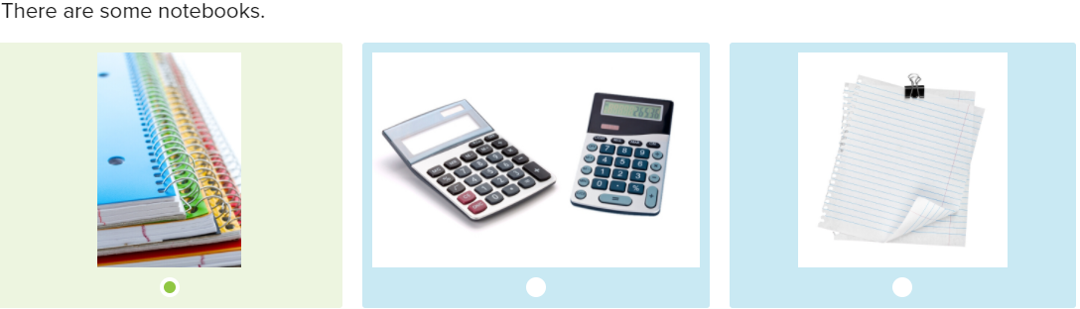

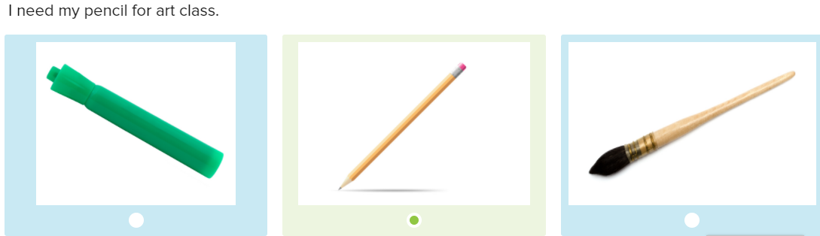

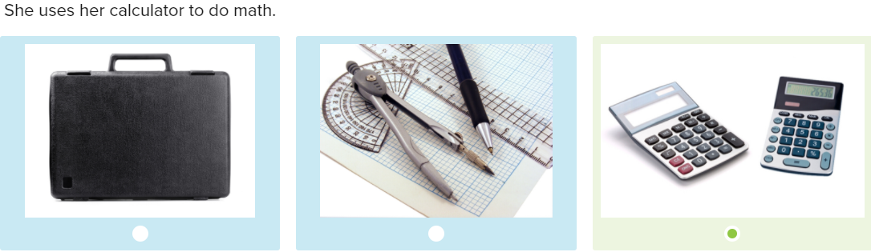

We learn addition and subtraction in math class

Do you like PE class?

-> Yes, I love tennis and soccer

You must bring pencils, paints, and colored markers to art class

What’s you favorite class?

-> My favorite class is biology because I like plants and animals

What do you study in history class?

-> I study about people and places

What do you learn about in English class?

-> I learn about grammar and spelling

**Skill practice**

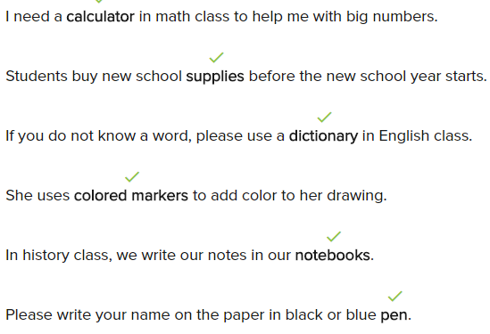

**Conversation**

Okay everybody, first we're going to study math. What do we need?

I need pencils, a calculator and our notebook

After math class, it’s time for art class, what do we need for art class?

We need our pencil, some color market and paper

Good, in the third class, we can learn about animals and plants. Which class is that?

That’s biology class

Great, after lunch you have English class. What do you learn in that class?

We learn spelling and grammar

Very good, after English, it’s time to play basketball. There anyone know what classes?

The last class is PE

**Exercise**

I don’t know the answer to this math problem. The numbers are too big

-> You can use my calculator

My dad knows a lot about plants and animals. He teaches biology at a university

The students write n their notebooks

My bag is very big because I have a lot ò books for my biology class

I am not good at learning languages

-> Well, you have to work hard in English class!

What class do I need my calculator for?

-> You need it for math class. We are adding ans subtracting big number

My best friend loves art, so he has lots of pencils and colored markers

Where can I learn about computer viruses?

-> In computer studies

22.1.2

Oh, that the start the few_. What do you doing?

I want to ask a question

What’s your question?

Where is regular teacher?

Could you repeat that?

Where is regular teacher? Hello

I’m sorry. I don’t know what to say I don’t have a script. And where is a camera. Hello! I need the script, I don’t know what to say

You need to teach about animals

My Mom say: temp teacher are always bad

Temp teacher?

When regular teacher said: we are have temp teacher for a day or two

This is a real class in a real school?

Yes, what do you think you are?

Okay students, today I’m teaching about animals. Open your book, to page one. Close your book. Now, what animal is this?

A lion

Yes, a lion. What do you know about lion?

Lion are from African

Yes. And what is this?

A duck

What do you know about duck?

They can fly and they can swim

That’s right. What’s this?

A fish

Who can tell me about the fish?

They live in the ocean

Correct!

Tree

What can you make with tree?

Paper

And houses, chairs, desks, a lot of things, anyway. What’s this?

It’s a cow

What do we get from cow?

Milk

Who can name this animal?

A rabbit

Right, a rabbit. And what do rabbit eat?

Carrot

What’s this?

That’s a flower

It’s a flower and animal

It’s a plants

That’s right

What does Shen think he is doing?

-->Acting in a movie.

When do temp teachers teach?

-->When the regular teacher is sick.

How does Shen teach the lesson?

-->He draws and asks questions

Why does Shen act like a lion?

--> To make the lesson fun.

